Capitalist side of China
Just when you've seen it all....
A Wedding in ShanXi
Traditionally a very poor region of China until the discovery of vast coal deposits.
Have a look at a wedding involving one of the coal boss' family.
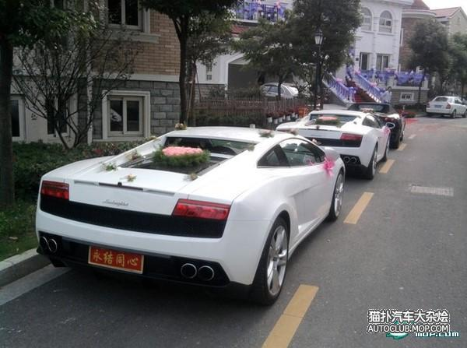
A Ferrari here can only be the escort car!
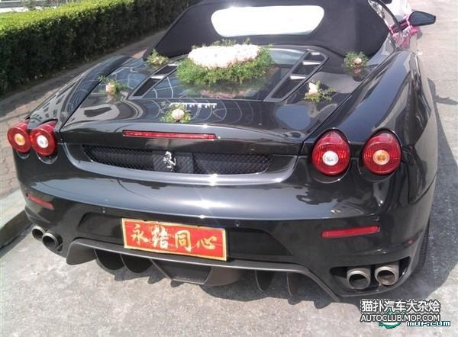
Wedding limo: Rolls-Royce Phantom
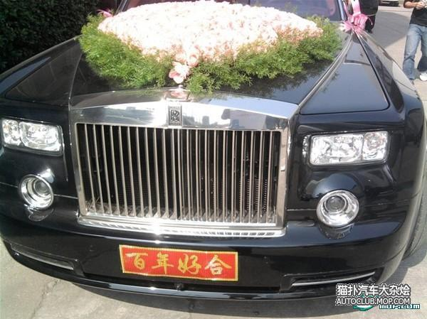
The Groom's house
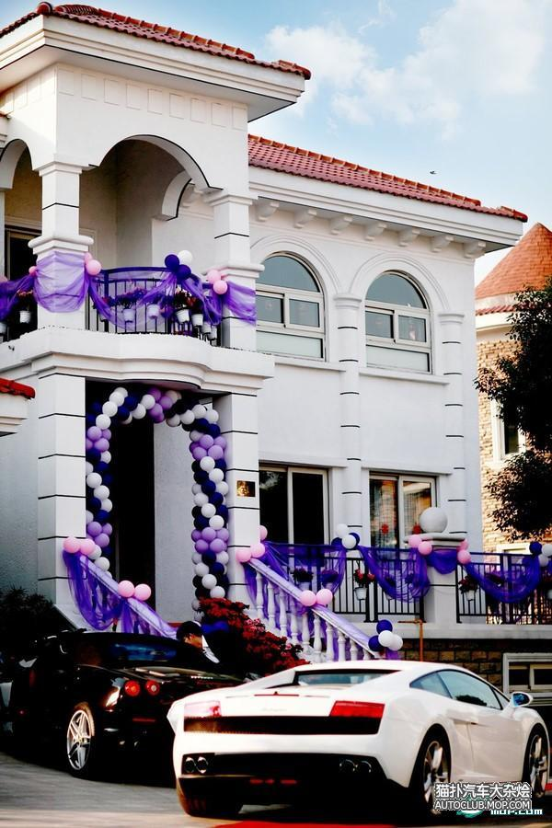
Part of the dowry (cheque, gold bars and gold rice bowl set)
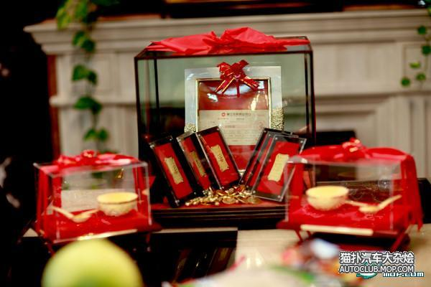
The Lambos are also part of the dowry!
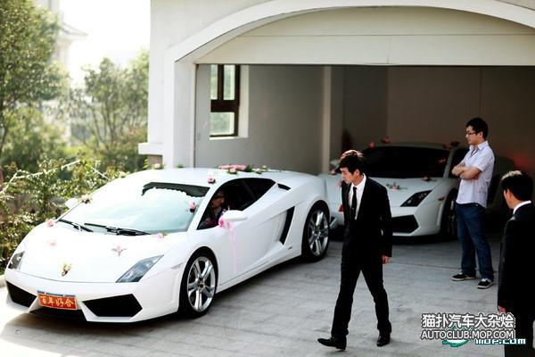
Groom with the best men "team"
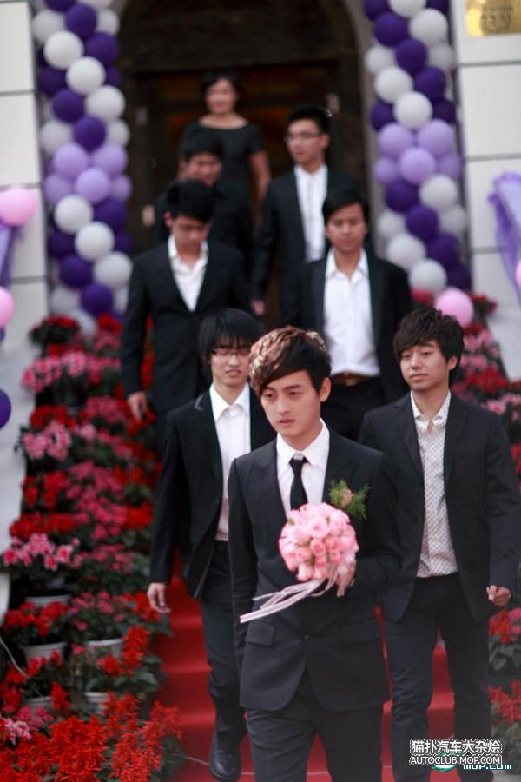
Picking up the bride
Bride's home
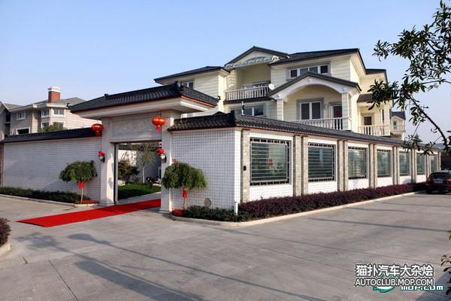
The lucky bride



Part of the escort team

$ 3,000 manicure, forget the diamond ring.
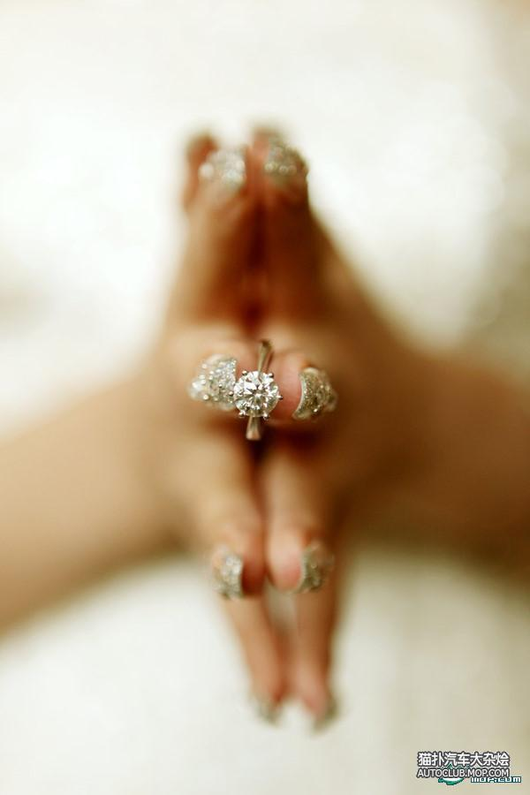
Giving the "Open the Door" Red Packets
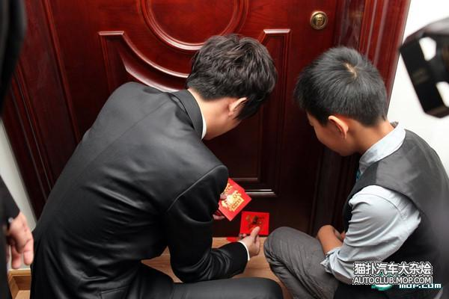
Receiving the red packets on the other side

Bride's family
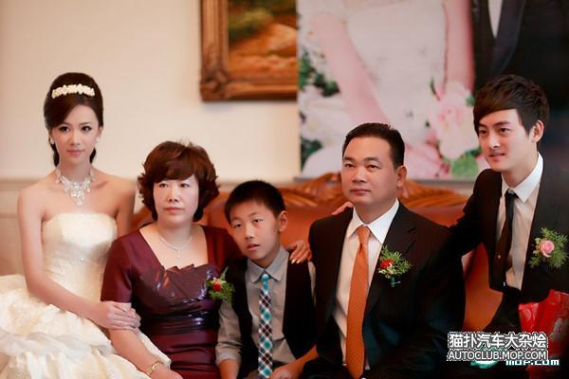
The wedding hall
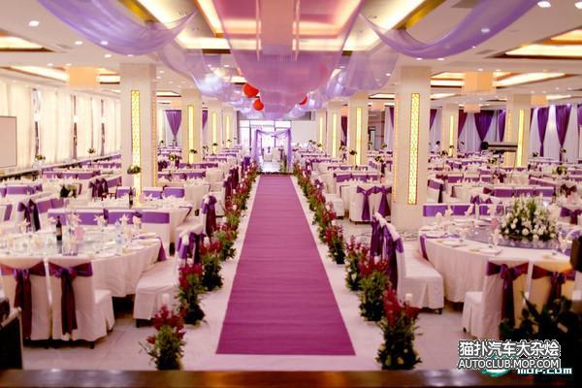
This is one fleet for a wedding on June 20, 2009 in Datong , a major city in Shanxi .
F360
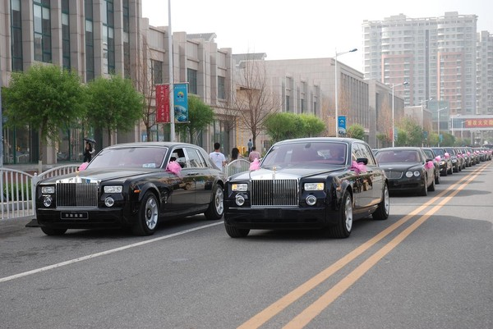
40 Porsche Cayennes, Range Rovers, BMW X5 and Audi Q7 are not counted as the wedding fleet, only escorts.
Classic Ferrari 575M
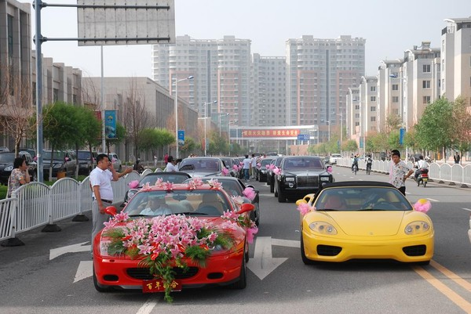
The escort team's job is to go ahead of the wedding fleet to "clear the road"!
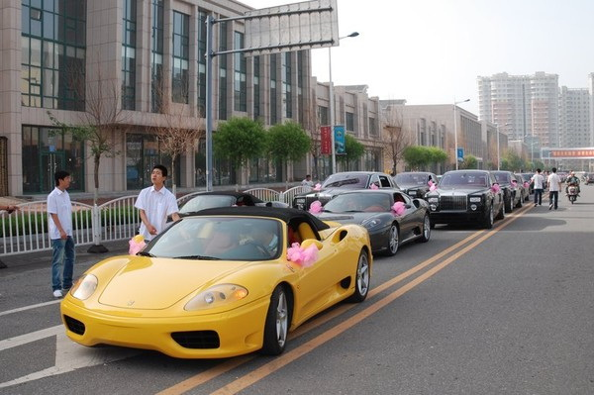
The camera team
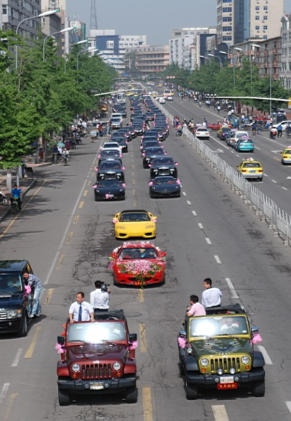
6 Jeeps as camera team
4 Ferrari leads
4 Rolls Royce main fleet
6 Mercedes
6 Bentleys
20 Audi A8s
Hummer at the back
Cayennes for "odd jobs"!!!!!!! !
Go have sleepless night

